**Project Report Template**

**Introduction**

**Overview :**

Canva is an online design and visual communication platform with a mission yo empower everyone in the world to design anything and publish anywhere.This app helps me to create a beautiful social media post which was the task that give to me There is lot of creative posters in this app.

**Purpose :**

Creating a social media post is very easy to do as a project only in Canva application. There is a lot of creative and beautiful designs to create a post.Everything is beautiful ,it is hard to select the beautiful designs among the extraordinary designs.Thus app really helps me a lot.

**Problem definition and Design Thinking**

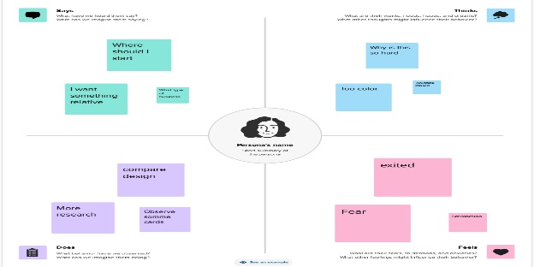 **Empathy map :**

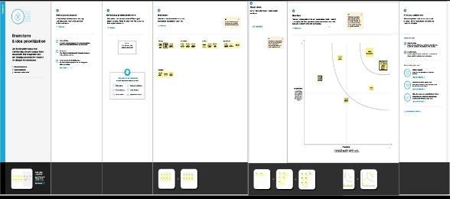 **Brain stroming map:**

**Result**

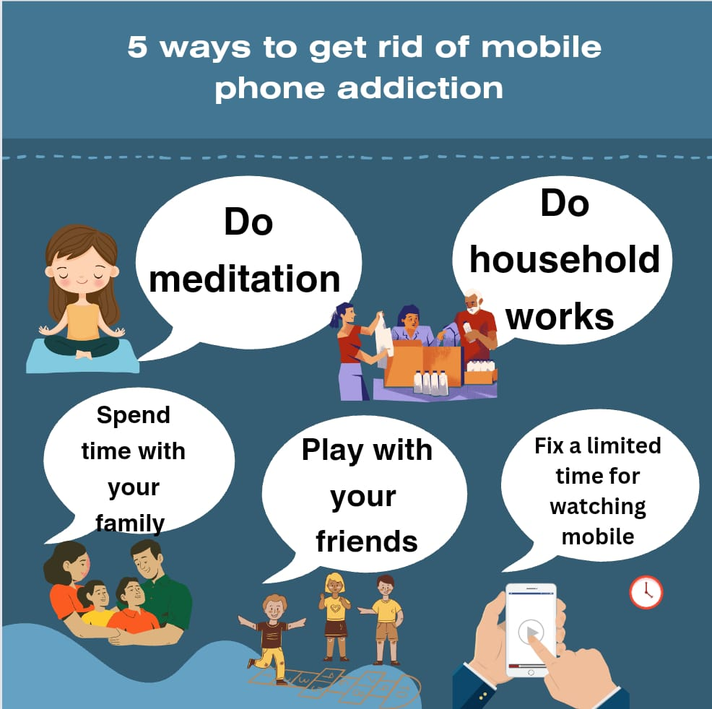

**Advantages and Disadvantages**

**Advantages:**

* A business get a chance to target,connect and reach the audience right at the time
* Social media poster provides that facilitation

**Disadvantages:**

* The poster reduces the face to face communication
* Lack of emotional connection

**Application**

Canva is commonly used for graphic design purposes. It can be used to create a wide range of visual content such as graphics,presentation,posters,logos,flyers,inforgraphics,and more.Canva has a user-friendly interface with various design templates,typography,images ,editing tool and making with a versatile tool for individuals ,business and organization.

**Conclusion**

In conclusion, creating a social media post project requires careful thought and planning. It is

important to consider the target audience, genre, and overall theme of the book when designing the

cover. The use of typography, color and imagery can greatly enhance the overall impact of the book

cover. Ultimately, successful book cover project will capture the attention of potential readers and

effectively convey the essence of the book